ST. ALOYSIUS
MEN’S CLUB
PRESENTS OUR 10th ANNUAL

BEN GRATZER MEMORIAL
EAGLE OPEN
(27th ANNUAL)

WHEN: Saturday, August 22, 2020
12:30 Registration (1:30 Shotgun Start)
REGISTRATION DEADLINE – (there is none)

WHERE: TPC Lagrange – Eagle Creek CC, Lagrange KY

COST: $85/person
Hole Sponsorship - $100.00
Super Hole Sponsorship (incl. 4-some) - $400.00

Typically, door prizes and event prizes/awards are an important and
enjoyable part of our event, as the prizes and, more important, the money thatis brought in is so vitally important to the core of our event goals….continued monetary support for our kid’s educational and athletic lives at St. Aloyisius.

Given the world climate we live in, we chose to effectively modify this year’s
event and eliminate both door prizes and event prizes, as we felt that asking
local merchants and partners to donate would be insensitive and incorrect, notto mention difficult. That said, we hope that a day of fellowship, great food
and refreshments, and also some good-to-average golf is enough to bring you
out with us on what we hope will still be a very relaxing and fun day.

Please call Mike Carr (502-377-0653), Brad Raybourne (303-931-6060),John Risimini (502-552-8460), and/or John Bestenlehner
(612-940-7926) if you are interested in playing, sponsoring a hole and/ordonating prizes. Please submit your entry as soon as possible. Make
checks payable to St. Aloysius and return, with registration form, to us atany of the below addresses:
Mike Carr
4712 Redbud Forest Place
Forest Springs North
Louisville, KY 40245

Johnny-B
10930 Keene Road
Craig's Creek
Louisville, KY 40241

Brad Raybourne
13503 Broken Branch Way
Forest Springs
Louisville, KY 40245

John Risimini
13500 Forest Bend Circle
Forest Springs
Louisville KY 40245

ST. ALOYSIUS
MEN’S CLUB
10th ANNUAL BEN GRATZER MEMORIAL
EAGLE OPEN GOLF SCRAMBLE
REGISTRATION FORM
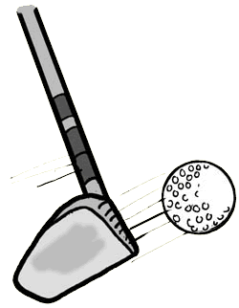

Name:

If entering as a team, please list the other team members below

Name:

Name:

Name:

Daytime Phone:

Hole Sponsorship:

